Family Living Competition

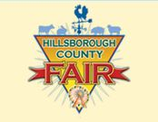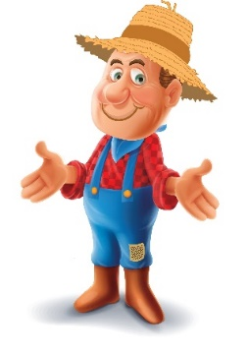 “From Wagon Wheels to Ferris Wheels”

September 23 – October 3, 2021

Table of Contents

# General Information for Family Living/Arts & Crafts…………… 2

A - JUST FOR KIDS DEPARTMENT………………………………….. 4

Kids Arts & Crafts – Kids Stitchery – Kids Creative Crafting

# B - CRAFT WORKS DEPARTMENT…...…………………………….. 5

Arts & Crafts – Paper Arts & Crafts – Jewelry - Decorative Arts - Holiday on Parade

1. - CREATIVE CRAFTING DEPARTMENT………………..……….... 7

Wood Crafting – Ceramics – Glass Crafting – 3D Art

1. - NEEDLEWORK DEPARTMENT……….………………………….. 9

Cross Stitch – Embroidery – Crewel Embroidery – Needlepoint – Quilts & Quilting

1. - HANDICRAFT DEPARTMENT……………….………. …………11

Knitting – Crochet – Basketry – Rug Hooking – Weaving – Tatting

1. - SEWING DEPARTMENT…………..………………..……….…...14

Fashion Competition

G - THE WORLD OF COOKING DEPARTMENT…………………...15

Food Preservation - Baking – Cake Decorating

H- INNOVATIVE MECHANICS DEPARTMENT………….…….…..18 Drones & Robotics

Exhibitor Entry Form …………………………………………… 19

**2021 HILLSBOROUGH COUNTY FAIR**

**General Information for Family Living/Arts & Crafts**

* **Pre-registered** entrants will receive one free admission ticket to the fair (per person not per item).

To preregister your entry: hillsborough.fairwire.com

1. Online Entry by **September 1, 2021** at:
2. Mail your completed, signed exhibitors’ entry form received **by September 1, 2021** to:

Hillsborough County Fair

Arts & Crafts

PO Box 100

Sydney, FL 33587

* All entries must be hand delivered to the fairgrounds one of the following times:

Friday, **September 17** from 5:00pm to 8:00 pm

Saturday, **September 18** from 2:pm to 6 pm.

Due to Covid-19: Baked goods will just be a recipe card and a photo of the completed project and will be accepted during both entry delivery times. We will not have judges tasting the baked goods this year.

* **The fair will not assume responsibility for returning such items as boxes, hangers or clothing bags delivered with items.**
* If entry form has not been pre-registered either online or mailed in, entries **must** be accompanied by a completed entry form.

### Release of Entries

* Articles entered must be picked up from the fairgrounds **on Monday, October 4,** between

10 am and 6 pm

* Articles being exhibited will not be released before the close of the fair.
* Items not picked up during the specified date and time will become the property of the Hillsborough County Fair.
* All baked goods will be discarded at the end of the first week of the fair.
* All premium monies and ribbons will be issued upon release of entries.

*Best of Show winners may have the opportunity to showcase their entries at the Brandon Library. Best of Show winners will be notified by the Hillsborough County Arts & Crafts Committee to be given instructions on item display and pickup.*

### Security

While all reasonable security will be taken, all entries are submitted at the risk of the exhibitor. With our new building, there is much improved security including doors which are locked during non-fair times and air conditioning to aid in the protection of exhibits. However, no claims for injury to any person or damage or loss of any property because of fire, theft or any other crime, shall be made against the Greater Hillsborough County Fair Inc., its officers or agents by or on behalf of the exhibitors.

### Judges/Judging

* Awards will be given on a merit basis as per the **Danish system.**
* All judges will be qualified.
* The decision of the judges is final.
* Consideration of judging will be given to appearance, design, technique, workmanship and finishing.
* Ribbons and/or Premiums will be paid based on the Judge’s scoring.
* Judging results will not be given over the phone.

### Eligibility

* This show is designed for work of amateur artists within Hillsborough County. *(An amateur is one who does not receive the major part of his or her income from the sale of his or her art. Visual Arts eligibility on first page of Visual Arts information.)*
* No entry fee is required.
* All articles entered must have been **completed within the last year**.
* Exhibitors may enter one article in each lot which is open to their age group. Exception: Food Preservation – see Food Preservation department page for details.
* All articles must be clean and must be the handiwork of the person entering the item.
* Entries are restricted to those that are a Hillsborough County resident OR are enrolled in a Hillsborough County School (public, private, homeschool, etc.) OR are a member of a Hillsborough County 4-H extension or FFA Chapter.

### Entry Specifics

* All decisions affecting this competition and interpretation of its rules are vested in the Greater Hillsborough County Fair.
* All articles entered will be displayed at the discretion of the Greater Hillsborough County Fair.
* No changes may be made to any entry after it is received.
* Each entry must be registered in its proper department, class, lot and age level. The Greater Hillsborough County Fair reserves the right to place any wrongfully registered entry into the proper category.
* Original design is defined as a modified pattern; changed stitches or elements from original pattern
* This year’s Fair Theme is *“From Wagon Wheels to Ferris Wheels”.* Any item fitting that description may be entered in this new lot.

**For any other questions, please contact: Janet Bone – Competitive Events Director at** [**competitveevents@hillsboroughcountyfair.com**](mailto:competitveevents@hillsboroughcountyfair.com) **or 813-737-3247 (fair office) or**

**Chassity White 813-955-9802 (cell) 9AM – 6PM ONLY!**

**A** **- “JUST FOR KIDS” DEPARTMENT**

**“Just for Kids” is open to Grades 1 through 5 only. There is no entry fee. A child may enter one item per lot. All entries must be clean, show quality and must be the handiwork of the child entering the article.**

#### Best of Show

#### Best of Show awards will be given at the discretion of the judges. Best of Show awards must go above and beyond the standard level of craftsmanship and may not be awarded per class/per lot.

Best of Show----…….Rosette and $25.00

#### Awards Per Lot/Per Division

1st Place ….. Blue Ribbon

2nd Place ……Red Ribbon

3rd Place ….White Ribbon

**NOTE: All LEGO and/or brick art MUST be submitted on a LEGO mat or attached to a hard surface for display purposes. A photo submitted with entry is appreciated.**

|  |  |  |
| --- | --- | --- |
| **CLASS 100 “Kids” Arts and Crafts** | | |
| **Lot:**  1. Basketry/Weaving | | 8. Fabric Items |
| 2. Painting on T-shirt/Sweatshirt | | 9. Recycled Art |
| 3. Jewelry | | 10. Sculpture (3-D art) |
| 4. Christmas Ornament | | 11. Brick kit (like Lego®) |
| 5. Dolls (not crochet or knitted) | | 12. Brick art – original design (like Lego®) |
| 6. Toys (not crochet or knitted) | | 13. Theme-based item |
| 7. Plastic Canvas |  | 14. Article Not Listed |
| **CLASS 110** | **“Kids” Stitchery** |  |
| **Lot:**  1. Quilting |  | 5. Vest |
| 2. Embroidery or Crewel Picture | | 6. Shorts |
| 3. Latch Hook Rug/Wall Hanging | | 7. Christmas Stocking |
| (*longest side not to exceed 30”)* | | 8. Crocheted or Knitted Item |
| 4. Pillow | | 9.Theme-based item |
| **CLASS 115 “Kids” Creative Crafting** | | |

**Lot:**

1. Ceramics – Fired Only
2. Ceramics – Original Design
3. Wood Crafting (no entry larger than 3 ft. x 3 ft.)
4. Stained Glass
5. Theme-based item
6. Article Not Listed

**B** - CRAFT WORKS DEPARTMENT

**Craft Works is open to Middle School, Secondary and Adult Divisions only. Primary Grades and Elementary are entered under “Just For Kids”. Exhibitors may enter one item per lot. (*No kits may be used.)* No entry fee is required. We cannot guarantee an electrical outlet for wired items.**

## Best of Show

#### Best of Show awards will be given at the discretion of the judges. Best of Show awards must go above and beyond the standard level of craftsmanship and may not be awarded per class/per lot.

Best of Show ………………………Rosette and $25.00

## Awards Per Lot/Per Division

1st Place …..Blue Ribbon

2nd Place …..Red Ribbon

3rd Place…. White Ribbon

|  |  |  |  |
| --- | --- | --- | --- |
| **CLASS 130** |  |  | **ARTS AND CRAFTS** |

**Lot:**

1. Dolls - Soft Sculptured* (*not crocheted or knitted)*
2. Dolls - Rag and Mop* (*not crocheted or knitted)*
3. Dolls – Others* (*not crocheted or knitted)*
4. Stuffed Animal* (*not crocheted or knitted)*
5. Teddy Bears* (*not crocheted or knitted)*
6. Plastic Canvas
7. Shell Craft
8. Bead Work
9. Leather Articles
10. Toys* *(not crocheted or knitted)*
11. Floral Table Arrangement
12. Pillows (*not crocheted, knitted or quilted)*
13. Calligraphy
14. Original Design
15. Theme-based item
16. Article Not Listed

**\***Enter crocheted or knitted Items under Crochet or Knitting

|  |  |  |  |  |
| --- | --- | --- | --- | --- |
| **CLASS 135** |  |  |  | **PAPER ARTS & CRAFTS** |

**Lot:**

|  |  |  |  |  |  |
| --- | --- | --- | --- | --- | --- |
| 1. Scrapbooking | | | | | 5. Paper Dolls |
| 1. Handmade cards | | | | | 6. Origami |
| 1. Paper Mache | | | | | 7.Theme-based item |
| 1. Quilling | | | | | 1. Article Not Listed |
| **CLASS 140** |  |  |  | **JEWELRY** | | |

**Lot:**

* 1. Necklace
  2. 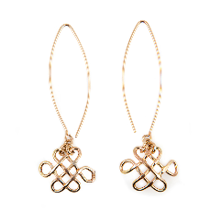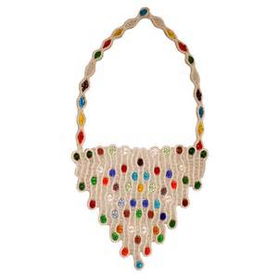Earrings
  3. Bracelet
  4. Rings
  5. Anklet
  6. Brooch/Pin
  7. Theme-based item
  8. Article Not Listed

|  |  |  |  |  |  |  |
| --- | --- | --- | --- | --- | --- | --- |
| **Class 145** |  |  |  |  |  | **DECORATIVE ART** |

Decorative Art is a diverse Art Form utilizing a variety of techniques and media to decorate functional and non-functional surfaces.

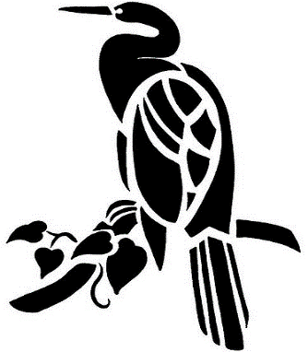**Lot:**

1. Fabric
2. Faux Finish
3. Miniature with easel – Image no larger than 3 x 3 inches
4. Silk
5. Stenciling
6. Porcelain/china painting
7. Original
8. Theme-based item
9. Article Not Listed

|  |  |  |  |  |  |
| --- | --- | --- | --- | --- | --- |
| **CLASS 150** |  |  |  |  | **HOLIDAY ON PARADE (All holidays accepted)** |

**Lot:**

|  |  |  |
| --- | --- | --- |
| 1. Table Centerpiece | 1. Handmade Christmas Tree (2 ft. maximum) | |
| 1. Wreath & Door Decoration | 1. Toys, Stuffed Animals (not crocheted or knitted) | |
| 1. Wall Hanging | 1. Dolls (not crocheted or knitted) | |
| 1. Table Top Accessory | 1. Dolls: Santas, Elves, Angels (not crocheted or knitted) | |
| 1. Christmas Stocking | 1. Painted Sweatshirt – Holiday Theme | |
| 1. Christmas Ornaments | 1. Plastic Canvas Items | |
| 1. Christmas Tree Skirt | 1. Theme-based items | |
| 1. Religious Decoration | 1. Article Not Listed | |
| 1. Home Accessory |  |

## C - CREATIVE CRAFTING DEPARTMENT

**Creative Crafting is open to Middle School, Secondary & Adult Divisions only. Primary and Elementary are entered under “Just For Kids”. Exhibitors may enter one item per lot. We cannot guarantee an electrical outlet for wired items. No entry fee is required.**

### Best of Show

#### Best of Show awards will be given at the discretion of the judges. Best of Show awards must go above and beyond the standard level of craftsmanship and may not be awarded per class/per lot.

Best of Show……………………..Rosette and $25.00

### Awards Per Lot/Per Division

1st Place……Blue Ribbon

2nd Place….. Red Ribbon

3rd Place…..White Ribbon

|  |  |
| --- | --- |
| **CLASS 160 WOODCRAFTING** | |
| **Lot:**  1. Train Set | 6. Rocking Animals |
| 2. Doll Houses | 7. Rocking Chairs |
| 3. Small Toys (cars, trucks etc.) | 8. Woodcarving |
| 4. Christmas Items | 9. Wood turnings (bowls, etc.) |
| (deer, tree, angel, etc.) | 10. Theme-based item |
| 5. Room Accessories 11. Article Not Listed    **No entry may be larger than 3 ft. x 3 ft. x 3 ft.** | |
| **CLASS 170 CERAMICS** | |

**Lot:**

1. Airbrush 6. Brushwork
2. Stains 7. Miscellaneous – Kiln fired only
3. Glaze 8. Theme-based item
4. Underglaze 9. Article Not Listed
5. Over

|  |  |  |  |  |  |
| --- | --- | --- | --- | --- | --- |
| **CLASS 180** |  |  |  |  | **GLASS CRAFTING** |

**Lot:**

* 1. Table Lamps

* 1. Sun Catchers
  2. Holiday Items
  3. Boxes and other 3-D Items
  4. Small Flat Panels

(*Capable of hanging in a window*)

* 1. Original Design
  2. Fused glass
  3. Theme-based item
  4. Article Not Listed

**NOTE: All LEGO and/or brick art MUST be submitted on a LEGO mat or attached to a hard surface for display purposes A photo submitted with entry is appreciated.**

|  |  |  |  |  |  |
| --- | --- | --- | --- | --- | --- |
| **CLASS 185** |  |  |  |  | **3D ART** |
|  |  |  |  |  |  |

**Lot:**

* 1. Sculpture
  2. Brick art – original design (like Lego®)
  3. Brick kit (like Lego®)
  4. Models (ex. Planes, cars, motorcycles)
  5. Theme-based item
  6. Article Not Listed

D **-** NEEDLEWORK DEPARTMENT

**Needlework is open to Middle School, Secondary & Adult Divisions only. Primary and Elementary are entered under “Just for Kids”. Exhibitors may enter one item per lot. No entry fee is required.**

### Best of Show

#### Best of Show awards will be given at the discretion of the judges. Best of Show awards must go above and beyond the standard level of craftsmanship and may not be awarded per class/per lot.

Best of Show…………..………Rosette and $25.00

### Awards Per Lot/Per Division

1st Place .....Blue Ribbon

2nd Place …..Red Ribbon

3rd Place ….White Ribbon

|  |  |  |  |
| --- | --- | --- | --- |
| **CLASS 190** |  |  | **CROSS-STITCH EMBROIDERY** |

**Lot:**

1. Cross Stitch on Clothing 10. Picture of Aida Cloth – over 14 ct
2. Cross Stitch on Pillow 11. Picture on Evenweave – 14 ct
3. Cross Stitch Wall Hanging or Bell Pull 12. Picture on Evenweave - +14 ct
4. Sampler on Aida Cloth 13. Picture on Linen
5. Sampler on Evenweave 14. Picture w Multiple Style Stitches
6. Sampler on Linen 15. Original Design
7. Sampler on Fabric not listed 16. Kit
8. Sampler w/ Multi-Style Stiches 17. Theme-based item
9. Picture on Aida Cloth – 14 ct 18. Article Not Listed

NOTE: Samplers and pictures may not exceed 30 inches on longest side and must be ready for hanging.

|  |  |  |  |
| --- | --- | --- | --- |
| **CLASS 200** |  |  | **EMBROIDERY** |

Lot:

1. Wall Hanging 9. Pillow – Completed
2. Picture (framed not to exceed 30” 10. Towels

on longest side) 11. Table Covers

1. Shirt, Blouse, or Skirt 12. Japanese Bunka Originals
2. Smocking on Clothing 13. Japanese Bunka Kits
3. Afghan 14. Original Design
4. Candle Wicking 15. Kit
5. Machine Embroidered Article 16. Theme-Based Item
6. Pillow Cases (pair) 17. Article Not Listed

**NOTE**: Linen, Cotton, Silk or Wool Thread on Natural Fiber Fabric.

|  |  |  |
| --- | --- | --- |
| **CLASS 210 CREWEL EMBROIDERY** | | |
| **Lot:**  1. Handbag | | 5. Kit |
| 2. Picture (*framed up to 30”on longest side)* | | 6. Original Design |
| 3. Pillow – Completed  4. Bell Pull or Wall Hanging | | 7. Theme-based item  8. Article Not Listed |
| **NOTE:** Wool Yarn ON Linen. |  | |
| **CLASS 220 NEEDLEPOINT** | | |

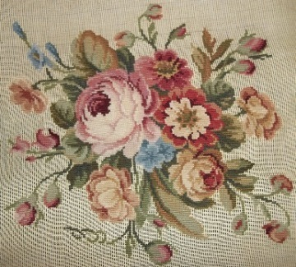  **Lot:**

|  |  |
| --- | --- |
| 1. Plastic Canvas | 9. Chair Seat, Footstool |
| 2. Pillow | 10. Wall Hanging |
| 3. Bargello | 11.Home Accessory |
| 4. Sampler | 12. Rug |
| 5**.** Picture (*not to exceed 30” on* | 13. Clothing |
| *longest side)* | 14. Kit |
| 6. Fashion Accessory | 15. Theme-based item |
| 7.Petit Point (*18 count canvas)* | 16. Article Not Listed |

8. Quick Point (*7 count or larger)*

|  |  |  |  |
| --- | --- | --- | --- |
| **CLASS 230** |  |  | **QUILTS AND QUILTING** |

**Lot:**

1. First Quilt
2. Pieced, Hand Quilted
3. Painted, Stenciled, Kit Quilts …..Hand Quilted
4. Quilts, Machine Quilting
5. Miniature Quilt ….. Hand Quilted
6. Crib Quilt…….Hand Quilted
7. Crib Quilt ……Machine Quilted
8. Group Quilt (*by 2 or more people)*
9. Comforter or Tied Quilt
10. Bed Cover – Novelty (*Cathedral, Yo-Yo, etc.)*
11. Wall Hanging, Bell Pull, Picture
12. Pillow
13. Animals, Dolls, Toys (*Pieced & Quilted)*
14. Original Design
15. Kit Quilt…..Machine Quilted
16. Pieced Quilt – machine quilted
17. Appliqued Quilt – hand quilted
18. Appliqued Quilt – machine quilted
19. Embroidered Quilt – hand quilted
20. Embroidered Quilt – machine quilted
21. Theme-based item
22. Article Not Listed

# E - HANDICRAFT DEPARTMENT

**Handicraft is open to Middle School, Secondary and Adult Divisions only. Primary and Elementary are entered under “Just for Kids”. Exhibitors may enter one item per lot. No entry fee is required.**

## Best of Show

#### Best of Show awards will be given at the discretion of the judges. Best of Show awards must go above and beyond the standard level of craftsmanship and may not be awarded per class/per lot.

Best of Show………………….….Rosette and $25.00

## Awards Per Lot/Per Division

1st Place…..…Blue Ribbon

2nd Place…..…Red Ribbon

3rd Place.….. White Ribbon

|  |  |  |  |  |
| --- | --- | --- | --- | --- |
| **CLASS 240** |  |  |  | **KNITTING** |

**Lot:**

1. Tablecloth 14. Pillow
2. Afghan 15. Home Accessory
3. Bedspreads 16. Machine Knitted Article
4. Infant’s Wear (*1-3*) 17. Pets
5. Child’s Wear (*4- up*) 18. Original Design
6. Adult Sweater 19. Repurposed materials
7. Adult Shawl 20. Hat
8. Clothing item not listed 21. Scarf
9. Vest 22. Jewelry
10. Doll & Doll Clothes – Holiday Theme 23. Socks/mittens
11. Doll & Doll Clothes –Other 24. Tote bags/purses
12. Toys & Animals – Holiday Theme 25. Theme-based item
13. Toys & Animals – Other 26. Article Not Listed

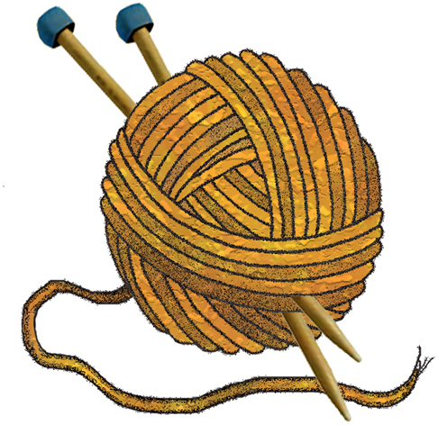

|  |  |  |  |  |  |
| --- | --- | --- | --- | --- | --- |
| **CLASS 250** |  |  |  |  | **CROCHET** |

**Lot:**

1. Tablecloth 13. Animals, Toys & Dolls (*Other)*
2. Small Table Cover 14. Pictures-*Not to* *exceed 30” on longest side*
3. Bed Cover 15. Home Accessory
4. Afghan 16. Original Design
5. Afghan – Infant Size 17. Pets
6. Infant’s Wear (1 – 3) 18. Repurposed material
7. Child’s Wear (4-up) 19. Hat
8. Adult Sweater/Shrug 20. Scarf
9. Adult Vest 21. Jewelry
10. Shawl/Cape/Stole 22. Sock/Mittens
11. Pillow 23. Tote bags/purses
12. Animal, Toys & Dolls 24. Theme-based item

(*Holiday Theme)* 25. Article not listed

|  |  |
| --- | --- |
| **CLASS 260** | **BASKETRY** |
| **Lot:**  1. Plaited | 5. Original Design |
| 2.Wicker | 6. Theme-based item |
| 1. Rib 2. Multiple Styles | 7.Article Not Listed |
| **CLASS 270** | **RUG HOOKING** |

**Lot:**

|  |  |
| --- | --- |
| 1. Traditionally Hooked – Primitive | 6. Braided |
| 2. Traditionally Hooked – Tapestry | 7. Latch Hook |
| 3. Novelty Items – Traditionally Hooked | 8. Kit |
| 4. Punch Hook | 9. Theme-based item |
| 5. Hali-Wool Fiber | 10. Article Not Listed |
|  |  |

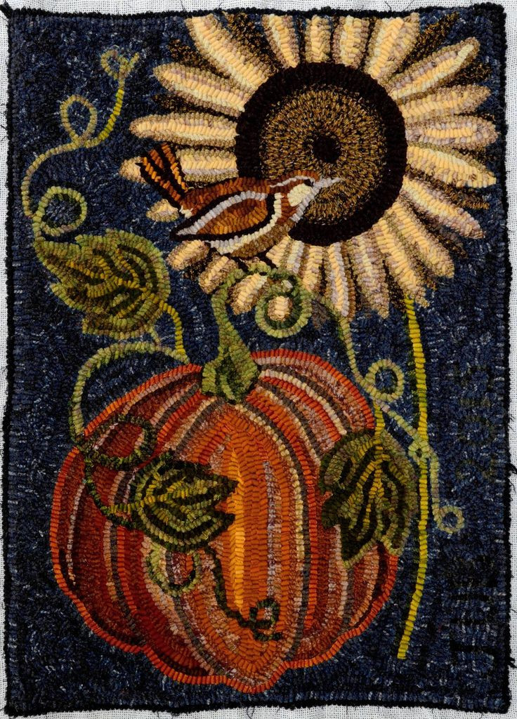

|  |  |  |
| --- | --- | --- |
| **CLASS 280** | **WEAVING** | |
| **Lot:**  1. Table Linens | 7. Sculptured Weaving |
| 2. Household Items | 8. Wearable |
| 3. Rug | 9. Kit |
| 4. Fashion Accessory | 10. Theme-based item |
| 1. Woven from Handspun Yarns 2. Hand Controlled (*Card, Finger)* | 11. Article Not Listed | |
| **CLASS 290** | **TATTING** | |

**Lot:**

1. Yardage
2. Bookmarks
3. Collars and/or cuffs
4. Doilies and/or placemats
5. Art piece
6. Jewelry
7. Theme-based item
8. Article Not Listed

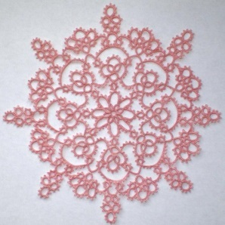 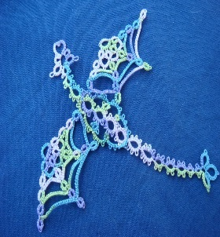

# F - SEWING DEPARTMENT

**Sewing Apparel is open to Middle School, Secondary & Adult divisions only. Primary**

**Grades and Elementary are entered under “Just for Kids”. Exhibitors may enter one item per lot. No entry fee is required.**

## Best of Show

#### Best of Show awards will be given at the discretion of the judges. Best of Show awards must go above and beyond the standard level of craftsmanship and may not be awarded per class/per lot.

#### 

Best of Show……..Rosette and $25.00

## Awards Per Lot/Per Division

1st Place.....…Blue Ribbon

2nd Place……..Red Ribbon

3rd Place…....White Ribbon

|  |  |  |  |  |
| --- | --- | --- | --- | --- |
| **CLASS 300** |  |  |  | **FASHION COMPETITION** |

**Lot:**

|  |  |
| --- | --- |
| 1. Accessory | 10. Suit (*any type)* |
| 2. Christening Set | 11. Wedding Apparel |
| 3. Coat (*any type)* | 12. Lingerie |
| 4. Dress (*any type)* | 13. Vest |

5.Jacket (*any type)* 14. Purses

6.Shirt (*any type)*  15. Tote Bags

7.Short Set *(mix & match)*  16. Repurposed materials (3 pcs)

8.Skirt and Blouse or Vest 17. Skirt

9.Slacks (*any type)* 18. Theme-based item

19. Any Other Article of Merit

**NOTE:** A coordinated outfit shall not exceed three pieces.

# G - THE WORLD OF COOKING DEPARTMENT

**The World of Cooking is open to Middle School, Secondary and Adult Divisions only. Exhibitors may enter one item per lot. No entry fee is required.**

## Best of Show

#### Best of Show awards will be given at the discretion of the judges. Best of Show awards must go above and beyond the standard level of craftsmanship and may not be awarded per class/per lot.

Best of Show ……………….…Rosette and $25.00

## Awards Per Lot/Per Division

1st Place…….…. Blue Ribbon 2nd Place………. Red Ribbon

3rd Place……….. White Ribbon

**Exhibitors may enter three (3) distinctive entries in each lot.**

|  |  |  |  |  |
| --- | --- | --- | --- | --- |
| **CLASS 310** |  |  |  | **FOOD PRESERVATION** |

**Lot:**

1. Dehydrated 8. Marmalades
2. Meat 9. Butter/Jams
3. Vegetables 10. Sweet Spreads
4. Fruit 11. Pickles, Relish and Salsa
5. Juice (*Fruit or Vegetable)* 12. Tomatoes
6. Vinegar 13. Article not listed
7. Jellies

**NOTE:** Consideration in judging will be given to appearance, design, technique, workmanship and finishing

**NOTE:** Entries must consist of two (2) jars of the same product. Jars must be clean, rings and lids should be free of rust. Regulation jars only…. No other jars will be accepted. Please do not decorate the jar or otherwise obscure the product. Recipe and processing method must be attached to product on 4 x 6 index card and must be typed or printed. All food must be prepared according to USDA recommended methods and placed in regulation canning jars filled to appropriate level. NO PARAFFIN. All recipes will be the property of the fair after submitted. Items must have been canned within the last twelve (12) months. Jellies, jams and other sweet preserves (except reduced sugar products) will be tasted as part of judging. All entries will be returned to exhibitor.

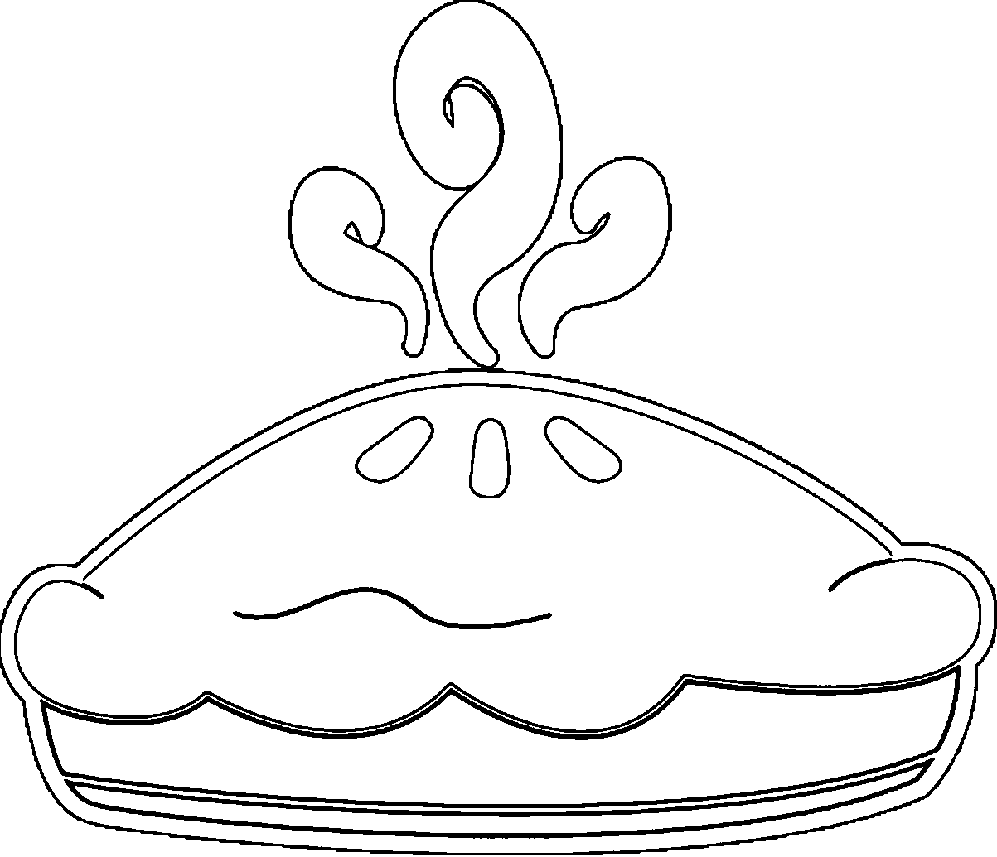

|  |  |  |  |  |
| --- | --- | --- | --- | --- |
| **CLASS 330** |  |  |  | **Baking** |

Baking Competition is open to Elementary (Gr. 1-5), Middle School (Gr. 6-8), Secondary, (Gr. 9-12) and Adult Divisions. Exhibitors may enter one item per lot. No entry fee is required.

Lot:

1. Breads 4. Two-Crust Fruit Pies 7. Whole Grain Items
2. Cakes 5. Candies 8. Citrus Items
3. Cookies 6. Any Modified Recipe 9. Article not listed

**Consideration in judging shall be given to texture, color, flavor and general appearance.**

**NOTE:**

* + **No mixes may be used. Entry must be accompanied by the recipe on a 4x6 card and must be either typed or printed. The recipe must be complete showing all ingredients used, as well as the method of preparation.** *(Name and address of the exhibitor must appear on the reverse side.)*
  + Entry will consist of one of cake, pie, bread or other single item. Cookies and candy entries must consist of six (6) pieces. All entries must be entered on disposable containers and placed in a plastic bag. *(Ziploc preferred*). All recipes become the property of the Greater Hillsborough County Fair.
  + Entries that require refrigeration will not be accepted.
  + Modified Recipe Competition – Lot # 6: Entry must have the original recipe on one 4x6 card and the modified recipe on another 4x6 card. • Custard-based pies, cakes and items containing custards will not be accepted.

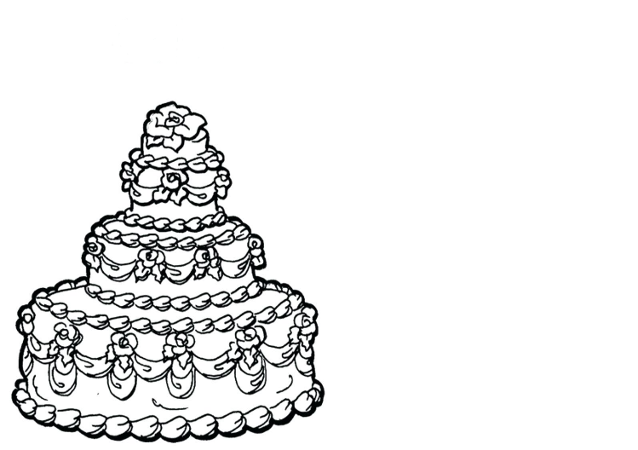

|  |  |  |  |  |
| --- | --- | --- | --- | --- |
| **CLASS 350** |  |  |  | **Cake Decorating** |

Baking Competition is open to Elementary (Gr. 1-5), Middle School (Gr. 6-8), Secondary, (Gr. 9-12) and Adult Divisions. Exhibitors may enter one item per lot, except for cupcakes in which you must enter no less than 3 and no more than 6. No entry fee is required.

Lot:  
1. Character 4. Fun 7. Theme  
2. Formal 5. Baby 8. Article not listed  
3. Holiday 6. Sports

Note:   
All cake or cupcake entries must be made with Styrofoam dummies or cake substitutes. Cakes can be single or multiple layers and may include decorations, such as, ribbons, photos, columns, supports, wires, stamens and more but only as embellishments and cannot make up the majority of the decoration. All entries must be the handiwork of the entrant.

*Consideration in judging shall be given to creativity, originality, skill, technique, neatness and overall appearance.

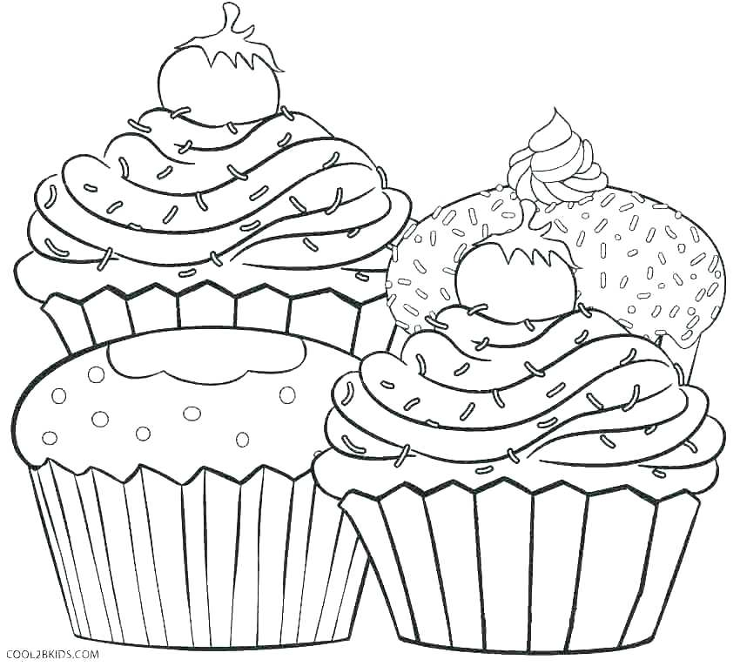

# H – INNOVATIVE MECHANICS DEPARTMENT

Innovative Mechanics is open to Elementary (Gr. 1-5), Middle School (Gr. 6-8), Secondary (Gr. 9-12) and Adult Divisions. Exhibitors may enter one item per lot. All work must be the handiwork of the person entering the item. No entry fee is required.

Best of Show

#### Best of Show awards will be given at the discretion of the judges. Best of Show awards must go above and beyond the standard level of craftsmanship and may not be awarded per class/per lot.

Best of Show……..Rosette and $25.00

Awards Per Lot / Per Division

1st Place……......Blue Ribbon

2nd Place…….......Red Ribbon

3rd Place………..White Ribbon

|  |  |  |  |  |
| --- | --- | --- | --- | --- |
| **CLASS 400** |  |  |  | **Drones** |

-*An unmanned aerial vehicle (UAV), a specialized robot that is meant to fly, (remote controlled)*

Lot:

1. Kit
2. Original Design
3. Article Not Listed

|  |  |  |  |  |
| --- | --- | --- | --- | --- |
| **CLASS 410** |  |  |  | **Robotics** |

*-A machine that performs various tasks automatically*

Lot:

1. Kit
2. Original Design
3. Article Not Listed

2021 Greater Hillsborough County Fair

“*From Wagon Wheels to Ferris Wheels””*

**Exhibitors Entry Form – Family Living/Arts & Crafts** (Please Print)

Name: __________________________________________________________________

***Division***: _____ Adult: 18 yrs.+ _____ Middle School: Gr. 6-8

_____ Secondary: Gr. 9-12 _____ Elementary: Gr. 1-5

Address: ________________________________________________________________

City: ______________________ Zip: ________ Phone:__________________________

Email: ______________________________________

Group/School/organization: _____________________________________________________

|  |  |  |  |  |  |
| --- | --- | --- | --- | --- | --- |
| *Ticket#*  *Filled in @ check-in* | *Dept.* | *Class* | *Lot* | *Rec’d By*  *Filled in @ check-in* | *Description* |
|  |  |  |  |  |  |
|  |  |  |  |  |  |
|  |  |  |  |  |  |
|  |  |  |  |  |  |
|  |  |  |  |  |  |

While all reasonable security will be taken, all entries are submitted at the risk of the exhibitor. With our new building, there is improved security and air conditioning to aid in the protection of exhibits. However, no claims for injury to any person or damage or loss of any property because of fire, theft or any other crime, shall be made against the Greater Hillsborough County Fair Inc., its officers or agents by or on behalf of the exhibitors.

**I hereby agree to abide by all rules and regulations of the Greater Hillsborough County Fair.**

**Signature of Exhibitor: ____________________________________**

**Date: ______________________**

**Office use Only Total Award Rec’d: _______________**

**Signature of Exhibitor:__________________________________________ Date:_________________**